[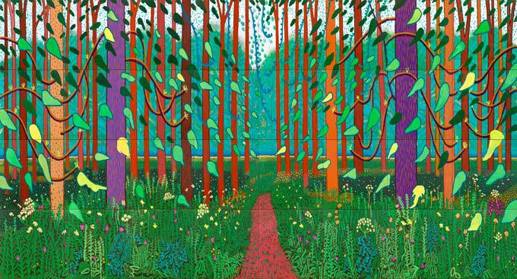](http://www.google.co.uk/url?sa=i&rct=j&q=&esrc=s&frm=1&source=images&cd=&cad=rja&docid=EI0GyJWKkaoTZM&tbnid=WBE9P-2rkPUZcM:&ved=0CAUQjRw&url=http://www.1883magazine.com/arts/arts/david-hockney&ei=YWNJUvm5A8XD7AaWjYDIBA&psig=AFQjCNFbWD_38lG46JpYJ0jwfuzF3YKWHQ&ust=1380627541528114)Gathering Information

**Content- looking at the subject of the work**

What is it? What is happening?

What does the work represent?

Title- what does the artist call the work?

Is it a realistic drawing/painting?

Have any parts been exaggerated or distorted? If so, why?

What is the theme of the work?

Key Words

**Landscape, portrait, view, journey, moment, memory**

**Form – looking at the formal elements**

What colours does the artist use? Why? How is the colour organised?

What kind of shapes can you find?

What kind of marks does the artist use?

What is the surface like?

What kinds of textures can you see?

**Light, delicate, layered, strong, rough, dark, dripped, textured, scale.**

**Painted, woven, printed, drawn, cast, stitched, manipulated, digital, layered, collage.**

Analysing a piece of Artwork

**Process- how the work has been developed and made**

What materials and tools have been used?

What is the evidence for this?

How has the work been made?

[](http://www.google.co.uk/url?sa=i&rct=j&q=&esrc=s&frm=1&source=images&cd=&cad=rja&docid=4neVWZs6Ak_vWM&tbnid=NRmZ1PorfHErlM:&ved=0CAUQjRw&url=http://www.michaelcraigmartin.co.uk/1990s/&ei=RmJJUvXFNdOg7AbcroHADQ&psig=AFQjCNGWd90Gh21rD-5iR_gCETWPzDHGOw&ust=1380627174742798)

**Quiet, loud, contemplative, thoughtful, hopeful, peaceful, elated, joyful, celebratory, reflective.**

**Ancient, abstract, modern, representational, historical, political.**

**Context – taking a wider view**

When was it made? Where was it made? Who made it?

Who was the work made for?

What do you know about the artist?

Does the work relate to the social or political history of the time?

How does the work relate to the works around it?

Can you link the work to other arts of the period, such as film, music or literature?

Does the work relate to other areas of knowledge such as science or geography?

**Mood- looking at the communication of moods and feelings**

How does the work make you feel?

Why do you think you feel like this?

Does the colour, texture, appearance or theme of the work affect your mood?